12 VOLT 30 AMP 115/230 VOLT SWITCHABLE AC POWER SUPPLY INFO
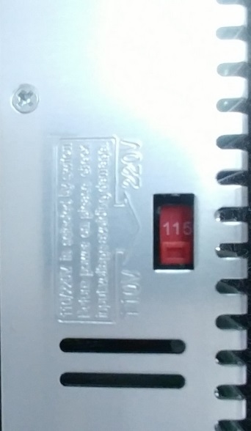 NOTE SWITCH POSITION RELATIVE TO THE HOUSING
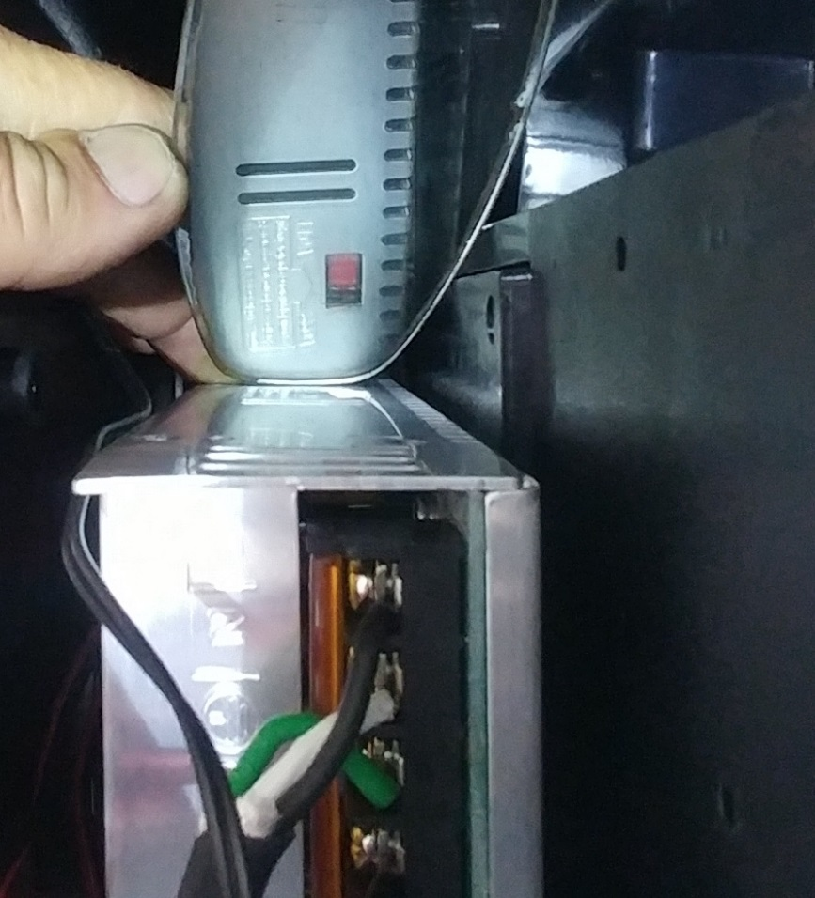USE A MIRROR WHEN INSIDE A CASE, WITH A FLASHLIGHT AND “DENTAL PICK” INSTRUMENT IF NEEDED
AC INPUT: L=LINE INPUT (BLACK) N=NEUTRAL (WHITE) GROUND = GREEN
+/- EACH HAVE 3 SCREWS, EACH CAN HOLD 2 WIRES FOR A TOTAL OF 6 OUTPUTS
QUESTIONS? CALL OR EMAIL FOR ALL TECH SUPPORT
CALL 310.534.4456 OR ADMIN@EEONTHEWEB.COM

